Report for Assignment 6 Shobhit Dhamania

Concurrency and Exception Handling by Language
Java
Concurrency model is shared-memory threads. Java uses java.lang.thread and shared mutable state like queues and lists, which basically protect data structures in terms of locks and thread safety. Workers are run through an executor service(a combination of 4 threads). Main thread basically delivers the worker runnables and does not create a thread explicitly. LinkedBlockingQueue<Task> is a shared task queue that blocks workers when no task is available. Shutdown is done through indentifier so wherever the worked gets the shutdown indentifier, it gets the command to exit the loop. Java depends exception based error handling. We use that that through InterruptedException and IOException. Workers handle task-specific errors inside a try-catch block so that our thread is not terminated if the worker failed the task.
Go
Go’s concurrency model is based on goroutines and channels(maybe goroutines came from coroutines). The goroutines are managed runtime and use buffered chan Task to pass work from the producer to worker. The worker then receives tasks over the channel and does the work. Sync.WaitGroup is the waiting of all workers to complete and sync.The mutex protects the final result. Go does not use exception handling like Java but instead has a return of (value, error) pairs, which must explicitly be checked. For failure panic and recover could be used and in the assignment, I used recover() to prevent the panic in one goroutine so that entire program doesn’t crash. Resource cleanup is then handled by defer.
Key Difference
Java uses shared-memory threads with locks and a blocking queue, whereas Go uses channels for communication rather than shared mutable state.

Conclusion
Both implementations achieve the same thing technically, but have different systems of operation and mechanisms. Java is more focused on shared thread management, and Go is lightweight concurrency by using channel-based communication and explicit error handling.

How to run -> I made a tasks.json in .vscode folder. Open the whole assignment 6 in vscode and go to terminal->Run tasks. Build Java and then Run Java and for Go just .. Run Go.
The tasks basically just have a manifest and information of what to do when clicked on those. Java and Go needs to be installed before opening visual studio code
Screenshots below ->
Java
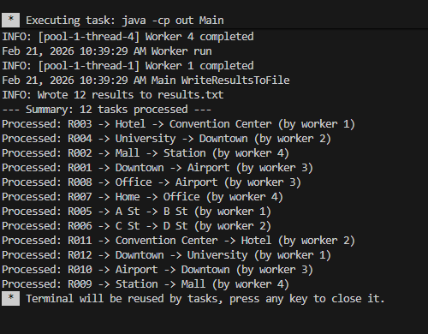
Go
